Modules and packages 2

Name – Archisman Roy 14/01/2021

CSE 2nd year 3rd sem

Roll – 50

Outputs-

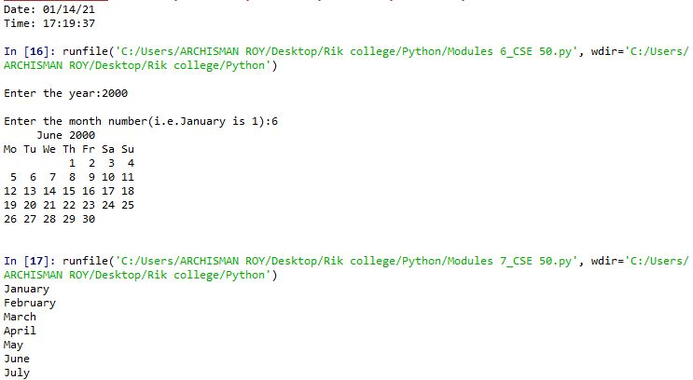

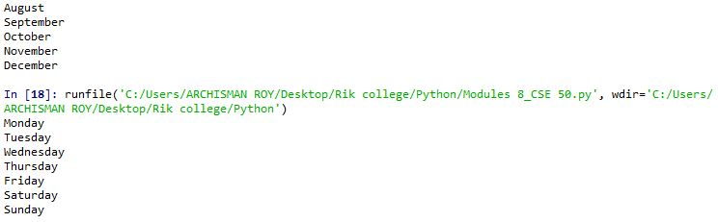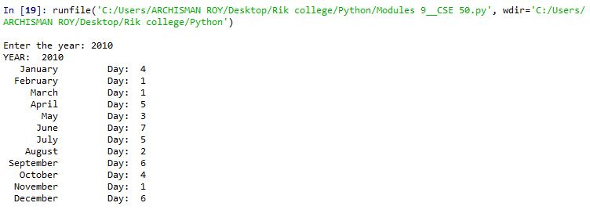

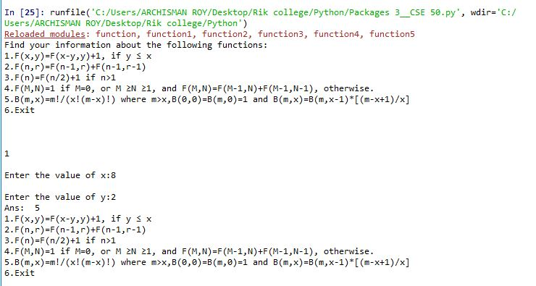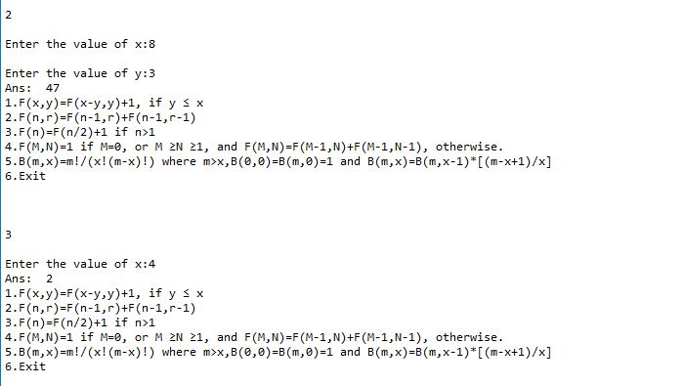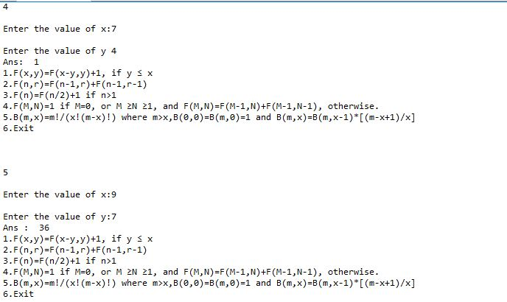

Questionnaire –

1. What is pip?

Ans. Pip is a package manager for Python.

That means it’s a tool that allows you to install and manage additional libraries and dependencies that are not distributed as part of the standard library.

Package management is so important that pip has been included with the Python installer since versions 3.4 for Python 3 and 2.7.9 for Python 2

The Python installer installs pip, so it should be ready for us to use, unless we installed an old version of Python.

1. How do you check whether it is installed or not?

You can verify that pip is available by running the following command in your console:

$ pip --version

pip 18.1 from C:\Python37\lib\site-packages\pip (python 3.7)

We should see a similar output displaying the pip version, as well as the location and version of Python. If we are using an old version of Python that does not include pip, then we can install it by following the instructions for our system in the pip installation documentation.

1. How do you check which packages of Python are installed?

Ans. Pip list and pip freeze will generate the list of installed packages.

The formats are different.

Pip list will generate a list of all installed packages.

Pip freeze will generate a list of packages that are installed by pip.